

**DISNEYLAND CHRONICLES: Insights from Guest Reviews**

***A text mining analysis***

**OPIM 5671: Data Mining and Business Intelligence**

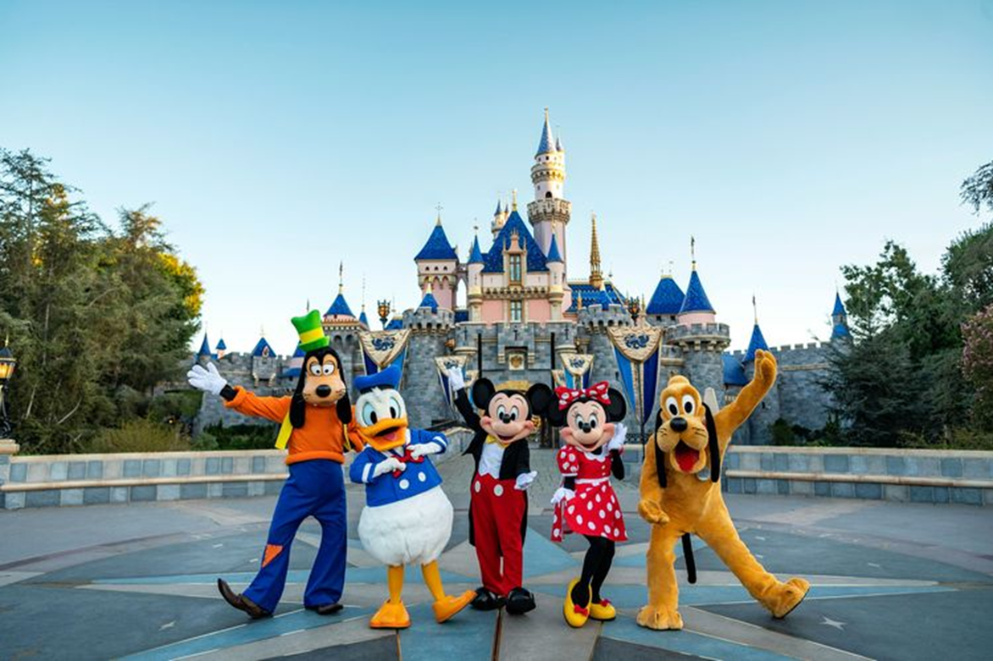

**Group 9: Hemanth Sai Kumar Bommina, Shivangi Chamoli, Khyathi Manne, Teja Sri Voota, Lohit Satya Sai chollangi**

**CONTENTS**

1. EXECUTIVE SUMMARY
2. INTRODUCTION
3. DATA PRE-PROCESSING
4. MODELING
5. BUSINESS INSIGHTS
6. RECOMMENDATIONS
7. CONCLUSION

* + - 1. **EXECUTIVE SUMMARY**

In the quest to explore and understand the vast array of guest experiences across Disneyland's global parks, our team embarked on a comprehensive text mining analysis. This project, titled "Disneyland Chronicles: Insights from Guest Reviews," aimed to dissect and analyze sentiments expressed in 42,000 guest reviews spanning Disneyland Paris, California, and Hong Kong. Our goal was to distill these sentiments into actionable insights, focusing on the enhancement of guest satisfaction and overall experience at these iconic destinations. By segmenting sentiments into positive and negative categories, our team identified critical areas for enhancement, notably concerns around food pricing and queue times. Furthermore, the analysis pinpointed specific attractions and experiences that are cherished by guests, guiding potential areas for future investment and marketing focus. The project provides a compelling roadmap for Disneyland to harness the wealth of data contained within guest feedback. Based on our analysis of the dataset we recommend implementing dynamic pricing strategies to add more value meal options, enhance queue management through the use of technology-driven solutions like virtual queue systems and app-based scheduling to minimize wait times, prioritize investments in attractions and experiences highlighted as favorites in guest reviews, utilize positive guest feedback in marketing campaigns to highlight what guests love most about Disneyland parks, establish a continuous feedback loop that leverages real-time data analytics to monitor guest satisfaction and operational efficiency, invest in comprehensive training programs for employees to enhance guest interactions and focusing on problem-solving, empathy, and customer service excellence. We also recommend examining the geographical backgrounds of reviewers may uncover patterns in regional tastes at Disneyland parks, allowing for the identification of visitor inclinations and reactions to certain attractions. As the parks continue to evolve and adapt based on guest feedback, Disneyland can reinforce its legacy as the premier destination for family entertainment, where every visit is as enchanting and memorable as the last. This project underscores the importance of listening to and learning from guest experiences, marking a path forward for continuous improvement and innovation in the quest to maintain Disneyland's esteemed place in the hearts of visitors around the globe.

**2. INTRODUCTION**

Disneyland, situated in Anaheim, California, is the inaugural theme park established by the Walt Disney Company. Opened on July 17, 1955, under Walt Disney's direct supervision, it has since become an iconic destination known for its magical experiences and immersive attractions. With expansions over the years, including the addition of New Orleans Square, Mickey's Toontown, and Star Wars: Galaxy's Edge, Disneyland continues to captivate visitors worldwide. It holds the record for the highest cumulative attendance of any theme park globally and remains a significant source of employment in the region. Through ongoing renovations and enhancements like "Project Stardust," Disneyland strives to maintain its status as a premier destination for entertainment and adventure.

Ticket prices for Disneyland vary depending on factors such as the type of ticket (single-day, multi-day, park hopper), the age of the visitor, and whether it's peak or off-peak season. Generally, single-day tickets for adults range from around $104 to $154, while multi-day tickets offer better value per day. Park hopper options allow visitors to access both Disneyland Park and Disney California Adventure Park on the same day for an additional fee.

As for people's reviews about Disneyland, they are often mixed but generally positive. Many visitors praise the park for its immersive attractions, magical atmosphere, and attention to detail. Families with children particularly enjoy the character encounters, parades, and fireworks shows. However, some guests may express concerns about long wait times for popular rides, crowded conditions during peak seasons, and high prices for food and souvenirs. Overall, Disneyland continues to be a beloved destination for people of all ages, drawing millions of visitors from around the world each year.

**About the dataset:**

The dataset includes 42,000 reviews of Disneyland having branches in Paris, California, and Hong Kong, taken from Kaggle.

**Link:**<https://www.kaggle.com/datasets/arushchillar/disneyland-reviews>.

Column Description:

1. Review_ID: unique ID given to each review.
2. Rating: ranging from 1 (unsatisfied) to 5 (satisfied)
3. Year_Month: when the reviewer visited the theme park.
4. Reviewer_Location: country of origin of visitor
5. Review_Text: comments made by the visitor.
6. Disneyland_Branch: location of Disneyland Park

These reviews are from October 2010 and May 2019 written in TripAdvisor, a popular travel website.  
We used JMP software for our initial analysis, we found that the majority of the ratings for all three branches (California, Hongkong, and Paris ) are positive ratings.

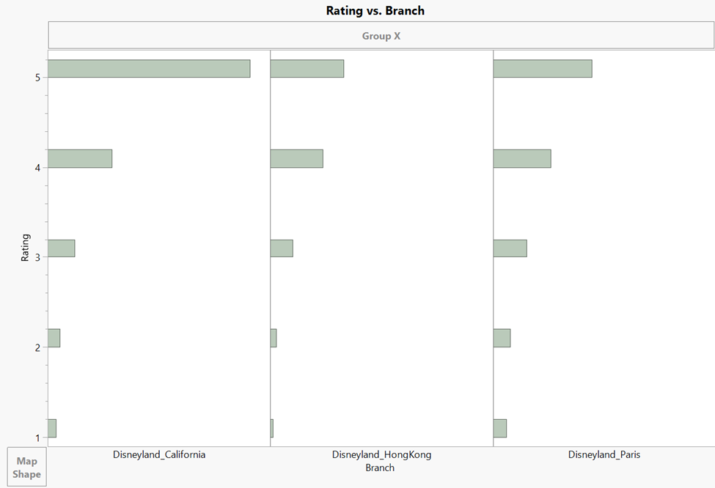

**Fig 1:** **JMP analysis of dataset**

We can see from the above figure that the rating for Disneyland California of 5 is more when compared to Disneyland Hongkong and Disneyland Paris.

Below are the branch wise ratings for ratings 1,2,3,4,5 for Disneyland California, Disneyland Hongkong, Disneyland Paris.

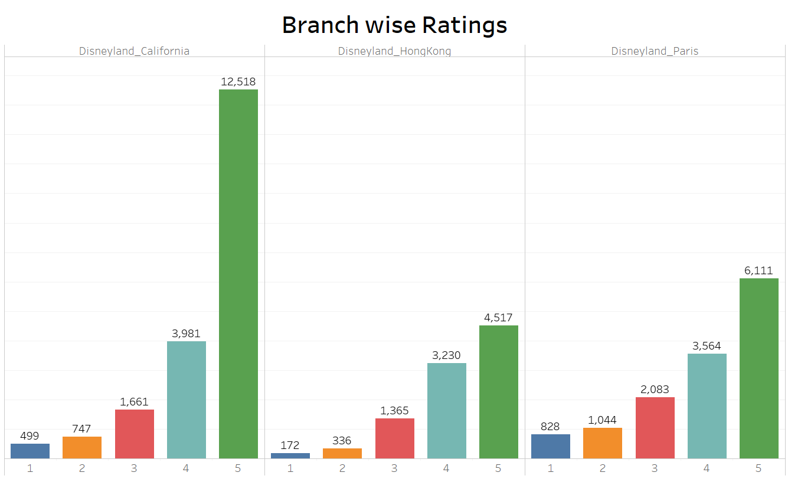

**Fig 2:** **Branch-wise ratings of Disneyland**

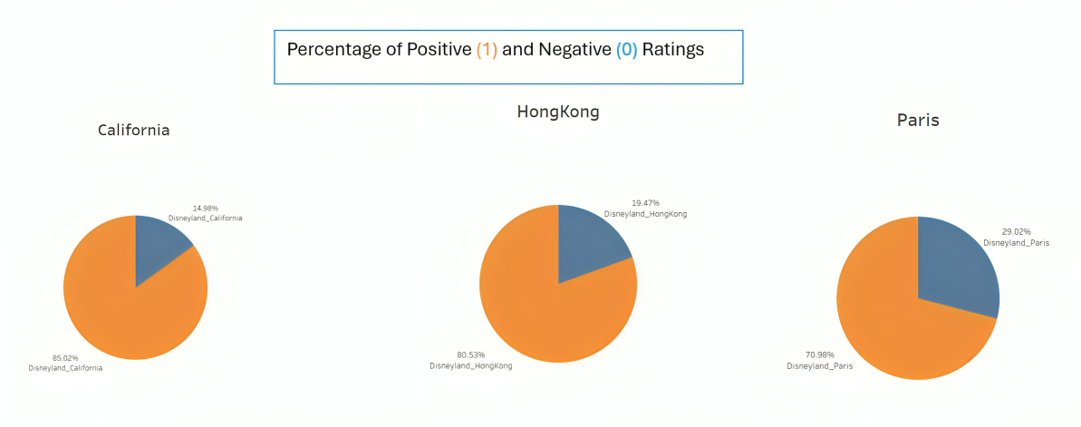**Fig 3: Percentage of positive and negative ratings** (Positive ratings are in Orange color and negative ratings are in blue color.)

* For Disneyland California Percentage of positive ratings (1) is 85.02%.And the percentage of negative ratings is 14.98%.
* For Disneyland Hongkong percentage of positive ratings (1) is 80.53%.And the percentage of negative ratings is 19.47%.
* For Disneyland Paris Percentage of positive ratings (1) is 70.98%.And the percentage of negative ratings is 29.02%.

**3. DATA PREPROCESSING**

We began by preprocessing the raw dataset to prepare it for analysis. This involved removing unnecessary columns such as Reviewer ID, Date of Review, and Reviewer Location. The dataset was then segmented into different files based on the park location, ensuring a more organized approach to our analysis.

**Categorization of Ratings:**

* To facilitate our analysis, we categorized the ratings into two groups using Excel formulas. Ratings one through four were grouped and labeled as 0, representing negative reviews.
* A rating of five was labeled as 1, representing positive reviews. This categorization was essential to ensure a balanced dataset for our model, given the disproportionate number of 5-star reviews compared to other ratings.
* Positive ratings are in Orange color and negative ratings are in blue color.

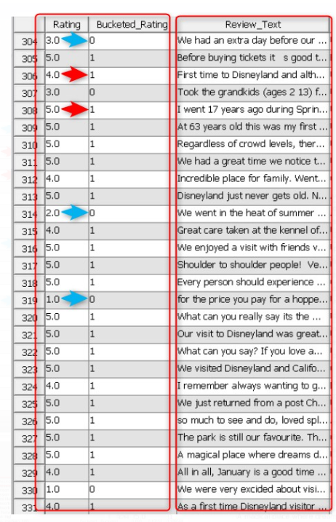

**Fig 4:** **Bucketing ratings of Disneyland**

**File Import:**

After preprocessing, we imported the dataset and set up the diagram appropriately, and once the design was set, we began to run the different combinations of models and text nodes.

**Selection of Input and Target Variables:**

* We identified the Review_Text column as our input variable, containing the textual data of the reviews. The Rating column was chosen as our target variable, representing the sentiment of the reviews.
* This selection enabled us to perform text analysis to uncover key insights from the reviews regarding guest experiences at Disneyland.

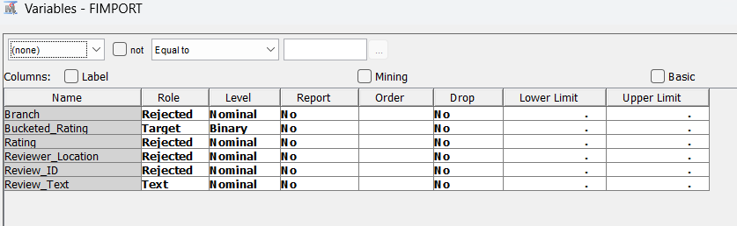

**Fig 5:** **File Import**

**Data Partition:**

A 50% training, 30% validation, and 20% testing split has been used. With this distribution method, our predictive models at various stages of development may be carefully evaluated. Our models have enough data to identify patterns and relationships because half of the dataset is used for training, which guarantees strong performance. As a crucial step, the 30% set aside for validation allows us to adjust model parameters and evaluate the model's capacity for fitting to new data. The final evaluation of model performance is provided by the 20% left over for testing, which says how well the chosen models should function with new, unproven information.

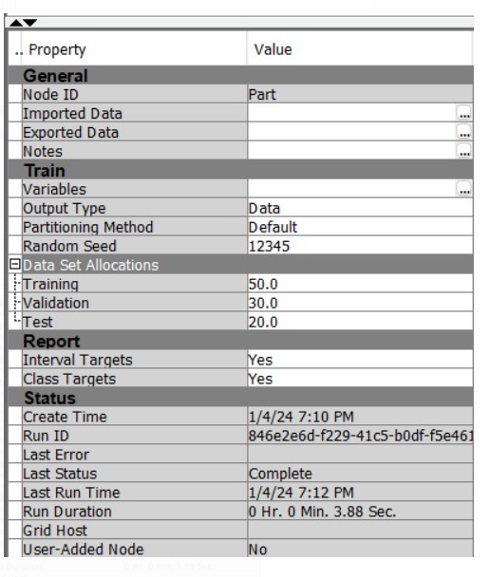

**Fig 6:** **Data Partition**

**Text parsing:**

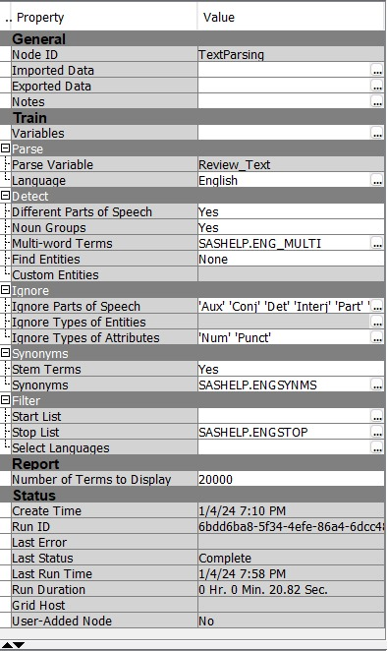

**Fig 7:** **Text Parsing**

**Stop Lists:**

We have created a custom stop list, as we could see the below terms are repeating more often and appearing in multiple documents , which would create a lot of noise in our analysis hence decided to not include in the analysis .Also Stop lists helps us to focus on the meaningful terms and improve the accuracy of the model. As we are working on a Disneyland review project the term Disneyland repeats a number of times and this word does not have much of an impact on the model and its accuracy. So we excluded a few words by adding them in the stop list based on the value they have on the model.

**Stop list for Disneyland California:**

These are the stop list for Disneyland California. As mentioned in the Disneyland California dataset as it revolves around the same branch so one of the most frequently repeated words that have not much of the impact on the model would be California and Disneyland as well.   
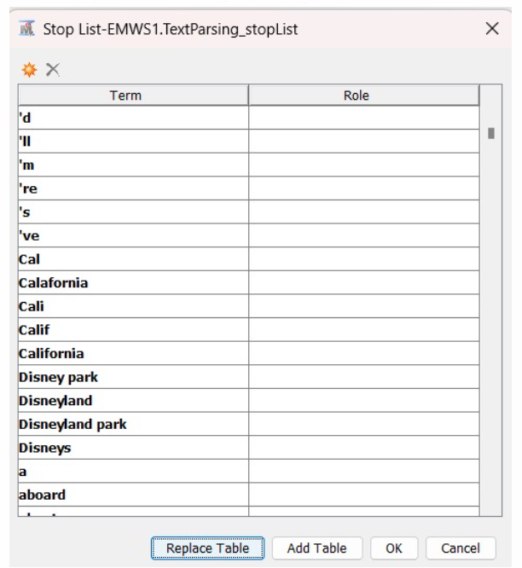

**Fig 8:** **Stop list for Disneyland California**

**Stop list for Disneyland Hong Kong:**

Similarly we have selected a few words for the Stop list of Hong Kong also and the words we have considered and used in the stop list are Disneyland , Disney , Hong Kong , HK , Disney Hongkong as these words did not add much of the value to the model we wanted.

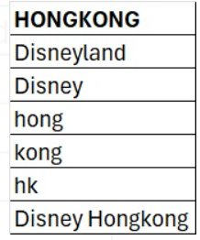

**Fig 9:** **Stop list for Disneyland Hong Kong**

**Stop list for Disneyland Paris:**

Similarly we have selected a few words for the Stop list of Paris also and the words we have considered and used in the stop list are Park , Disney , People , Disneyland.

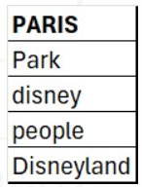

**Fig 10:** **Stop list for Disneyland Paris**

**Text Cluster**

We have taken the text clusters with changing the SVD resolutions as low , medium and high and also max SVD dimensions with low -100, medium-100 and high -70 in order to find out the best model from all the possible combinations the below picture is the text cluster for medium 100 similarly we did for the low 100, and high 70 but we observed the highest accuracies at medium 100 sentiment level.

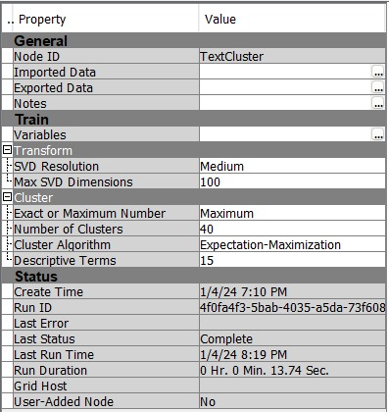

**Fig 11:** **Text Cluster**

In particular, we noticed that clustering Disneyland California, Disneyland Paris, and Disneyland Hong Kong proved to be highly successful when we focused on value.We were able to achieve the highest accuracy in differentiating between the Disneyland branches by focusing on the medium sentiment level.

**Text Filter:**

We consistently applied a log frequency weighting scheme while rotating between various term weight selection methods such as Mutual Information, Inverse Document Frequency, and Entropy. Within the Text Clusters analysis, we experimented with three distinct SVD values, representing Low, Medium, and High levels of decomposition. Similarly, we upheld a binary frequency weighting strategy and applied a parallel methodology for term weight selection and exploration within the Text Clusters.`

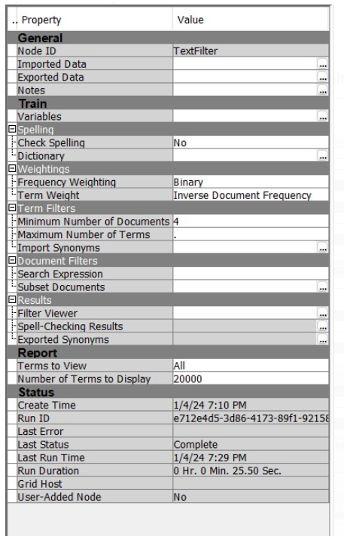

**Fig 12:** **Text Filter**

we performed all possible combinations by changing the frequency weight and term weight in all possible outcomes we observed that for the model with the highest accuracy has a text cluster with the frequency weighting as binary and term weight as inverse document frequency with SVD medium 100 the above is the text filter for the model with highest accuracy

**4. MODELING**

**4.1 MODELING FOR DISNEYLAND CALIFORNIA:**

For modeling the California we have separated the cumulative data into 3 different data sets Paris ,California and Hong Kong and bucketed the ratings and taken 1-3 as 0 indicated as negative reviews and 4,5 as 1 indicating the positive reviews and have taken the bucketed rating as the target variable and considered it as binary because it depicts the true or false case rejected the rest and while iterating the model created a new diagram and imported only the California dataset

We have tried the all the possible combinations starting with the text cluster we have 3 dimensions and resolutions low -100,medium -100 and high -70 and then with text filter initially we ran models with taking combinations of log-mutual information, log-inverse document frequency and log -entropy for all these text cluster and text filter combinations we ran the 4 models regression, decision tree, neural network and gradient boosting and added all these nodes to the model comparison node to compare the models and verify which model drives the best accuracy and as we see in the below image

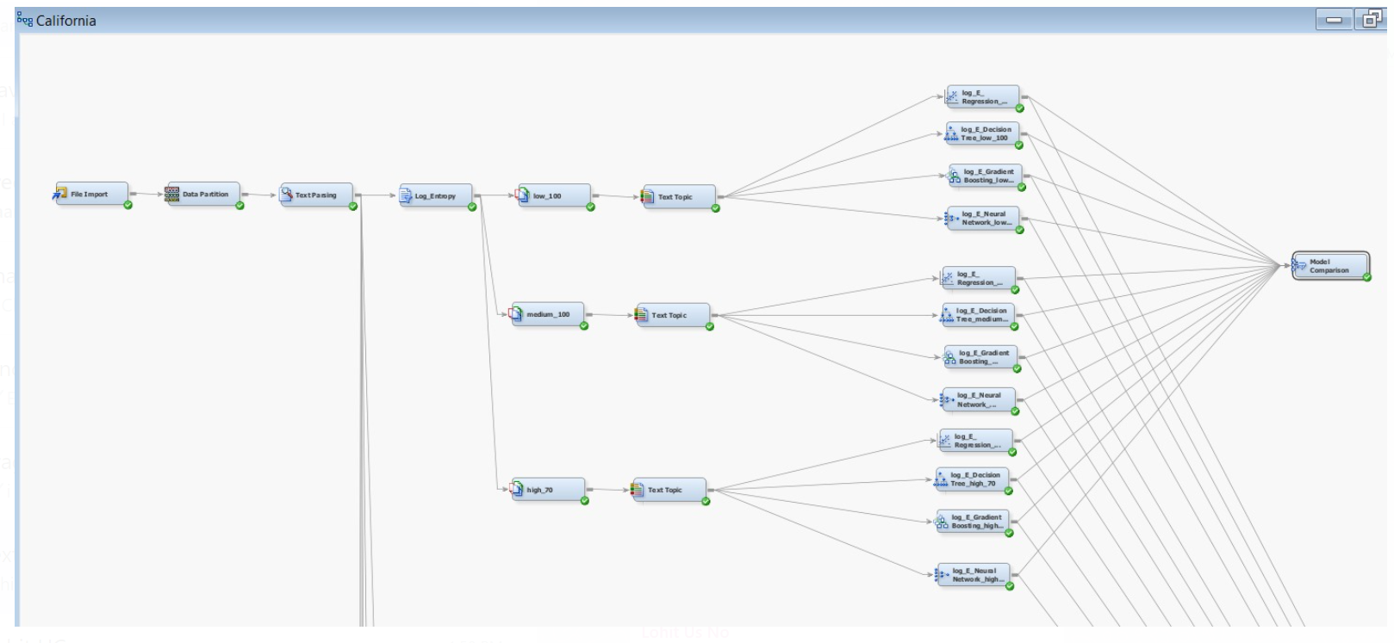

**Fig 13:** **Modeling for Disneyland California**

That is only the image for the one of the combinations of the text filter and text cluster for the model in the similar we way we ran the model for all the combinations possible and compared the accuracies.

As we did the combinations in the text filter like log-mutual information, log-inverse document frequency and log -entropy in the similar way we tried the combinations of binary-mutual information, binary-inverse document frequency and binary -entropy taking the same text filter and text cluster combinations and compared the model and have compared all the models to one model comparison to check which model has the best accuracy.

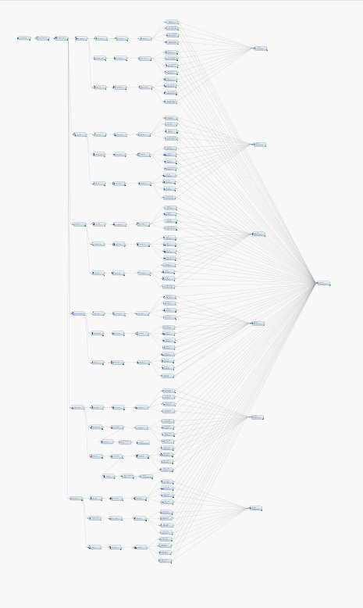

**Fig 14: Final Model for Disneyland California**

This is the final model with all the combinations with text clusters low -100,medium-100 and high 70 and text filters with combinations log-mutual information,log-inverse document frequency and log -entropy and also binary-mutual information,binary-inverse document frequency and binary -entropy with 4 models regression,neural network,gradient boosting and decision tree for all these combinations and finally added to node model comparison to compare and check the model with best accuracies

we can see that below is the output after we ran the model and we can see tha**t** This is output for Disneyland California and the highlighted mark indicates the accuracy which is highest from the all models which is 90 percent for Binary IDF for Regression model when the value for medium is 100.

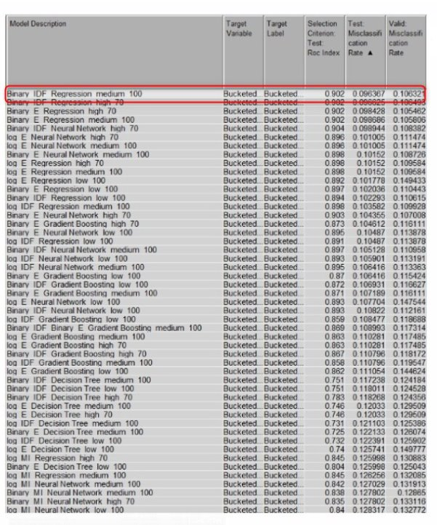

**Fig 15: Best Model for Disneyland California**

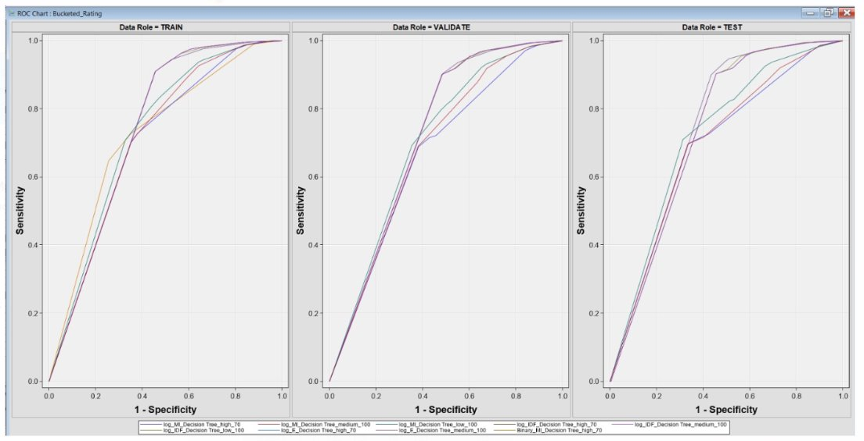

**Fig 16: ROC Curve for Disneyland California**

The curves for three different sets of data: training, validation, and testing. These are used to evaluate the performance of a binary classifier system, in our case, classifying reviews from Disneyland California as negative (0) for ratings 1-3, and positive (1) for ratings 4-5.

**Interpretation:**

* Plots on the Y-axis indicates the proportion of actual positives correctly identified by the model
* Plots on the X-axis indicate the proportion of actual negatives incorrectly identified as positive by the model.
* A curve that is closer to the top-left corner indicates a better-performing model, as it suggests a higher true positive rate and a lower false positive rate.
* **Validation Set:** The curve is closer to the top-left corner, indicating a good balance between sensitivity and specificity. The model generalizes well on the validation set, which is used to tune the model parameters.
* **Test Set:** The ROC curve is likewise fairly close to the top-left corner. The close association of these curves suggests that the model's performance remains stable across various setups or decision criteria. Given that the curves in the validation and test sets are closer to the top-left corner of the graph, the model appears to have strong predictive power for identifying reviews as positive or negative.

**4.2 MODELING FOR DISNEYLAND HONGKONG:**

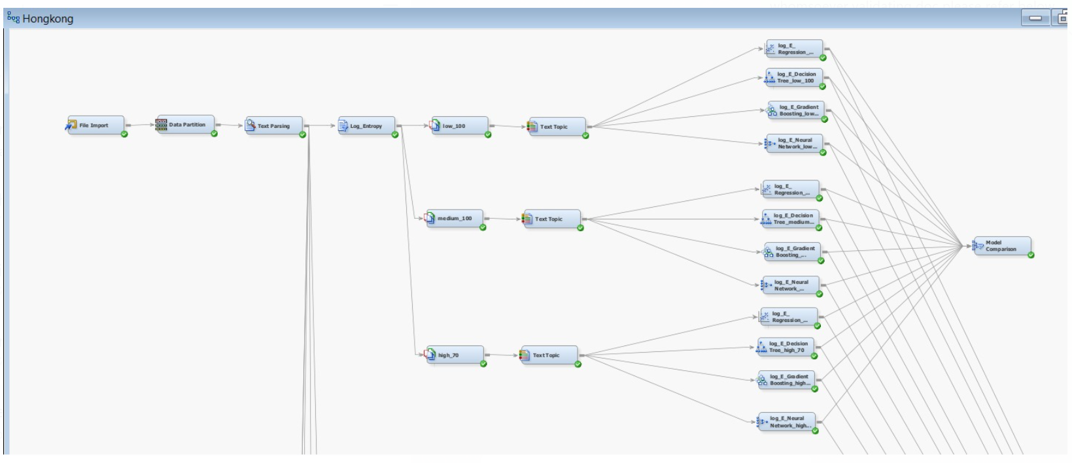

**Fig 17: Modeling for Disneyland Hong Kong**

For modeling the Hong Kong we used the same procedure which used for California we have separated the cumulative data into 3 different data sets Paris ,California and Hong Kong and bucketed the ratings and taken 1-3 as 0 indicated as negative reviews and 4,5 as 1 indicating the positive reviews and have taken the bucketed rating as the target variable and considered it as binary because it depicts the true or false case rejected the rest and while iterating the model created a new diagram and imported only the Hong Kong dataset. We have tried the all the possible combinations starting with the text cluster we have 3 dimensions and resolutions low -100,medium -100 and high -70 and then with text filter initially we ran models with taking combinations of log-mutual information,log-inverse document frequency and log -entropy for all these text cluster and text filter combinations and also for binary-mutual information,binary-inverse document frequency and binary -entropy we ran the 4 models regression,descisiontree,neural network and gradient boosting and added all these nodes to the model comparison node to compare the models and verify which model drives the best accuracy and as we see in the below image we can see the highlighted mark the accuracy is 83 percent for Binary IDF for Regression model when the value for medium is 100.

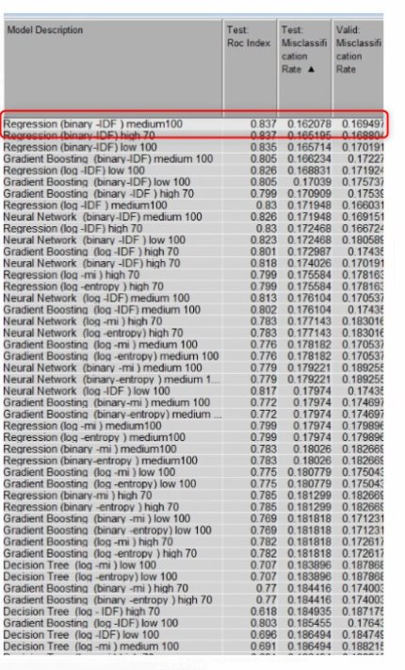

**Fig 18: Best Model for Disneyland Hong Kong**

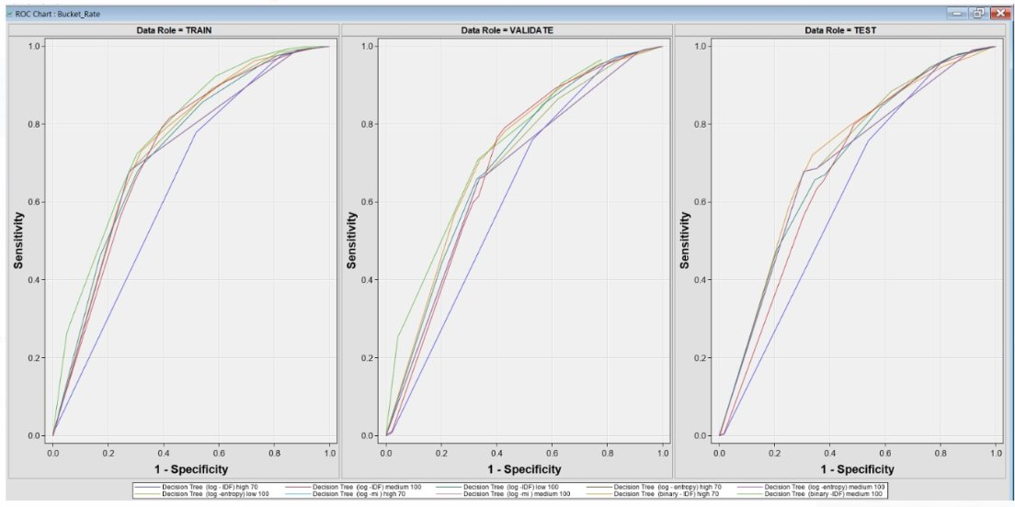

**Fig 19: ROC Curve for Disneyland Hong Kong**

The ROC curves for the Disneyland Hong Kong dataset They're used to assess how well your classification model can distinguish between negative reviews (ratings 1-3, marked as 0) and positive reviews (ratings 4-5, marked as 1)

**Interpretation:**

* Validation Set ROC: This curve, which is towards the upper left corner, indicates that the model is strong and predictive, indicating that it is able to adapt effectively to data that it was not trained on.
* Test Set ROC: Evaluates the model's performance using a different, previously unseen set of data in an effort to mimic real-world use. For the model to function successfully in practice, a good extension to new data is shown by a curve in the upper left corner.

If the ROC curves for the test and validation sets are both close to the top-left corner and to the training set curve, it suggests that the model has a good predictive power and is likely not overfitting. If the model performs consistently across training, validation, and test sets, this indicates a robust model that should perform well in real-world scenarios, classifying the reviews of Disneyland Hong Kong effectively into negative and positive categories.

**4.2 MODELING FOR DISNEYLAND PARIS:**

For modeling the paris we used the same procedure which used for california we have separated the cumulative data into 3 different data sets paris ,california and hong kong and bucketed the ratings and taken 1-3 as 0 indicated as negative reviews and 4,5 as 1 indicating the positive reviews and have taken the bucketed rating as the target variable and considered it as binary because it depicts the true or false case rejected the rest and while iterating the model created a new diagram and imported only the paris dataset we have tried the all the possible combinations starting with the text cluster we have 3 dimensions and resolutions low -100,medium -100 and high -70 and then with text filter initially we ran models with taking combinations of log-mutual information,log-inverse document frequency and log -entropy for all these text cluster and text filter combinations and also for binary-mutual information,binary-inverse document frequency and binary -entropy we ran the 4 models regression,descisiontree,neural network and gradient boosting and added all these nodes to the model comparison node to compare the models and verify which model drives the best accuracy

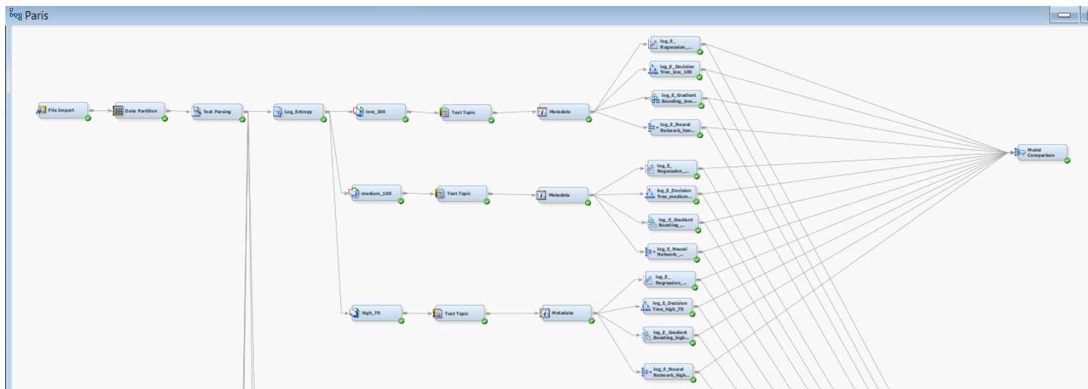

**Fig 19: Modeling for Disneyland Paris**

As we see in the image below, the Regression model using IDF as the global term weight, Binary as the local term weight, and SVD set at 100 with medium resolution exhibited superior performance compared to other models. It achieved a misclassification rate of 0.236 and an ROC index of 91.

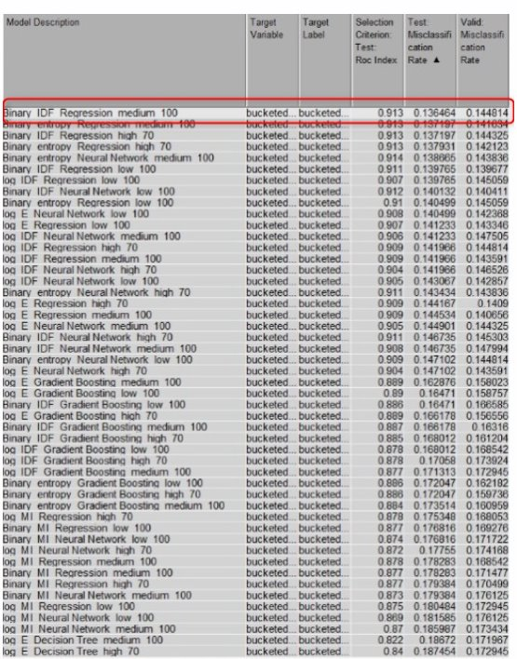

**Fig 20: Best Model for Disneyland Paris**

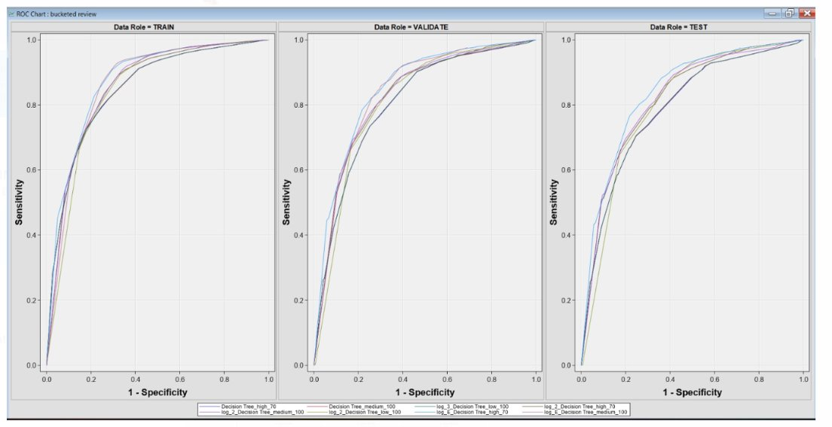

**Fig 20: ROC Curve for Disneyland Paris**

The curves for three different sets of data: training, validation, and testing. These are used to evaluate the performance of a binary classifier system, in our case, classifying reviews from Disneyland California as negative (0) for ratings 1-3, and positive (1) for ratings 4-5.

**Interpretation:**

* Plots on the Y-axis indicates the proportion of actual positives correctly identified by the model
* Plots on the X-axis indicate the proportion of actual negatives incorrectly identified as positive by the model.
* A curve that is closer to the top-left corner indicates a better-performing model, as it suggests a higher true positive rate and a lower false positive rate.
* Validation Set : the curve is close to the top-left corner, it indicates that the model generalizes well to the validation set
* Test Set: A curve near the top-left corner in the test set suggests that the model should perform well on new, unseen data

Considering that the validation and test curves are similar and close to the top-left corner, the model appears to be stable and not overfitting to the training data. It suggests that the model has good predictive power for classifying reviews into negative and positive categories based on the ratings given by visitors to Disneyland Paris.

**Negative and Positive words:**

The below highlighted words with red color are found to be Positive words and Blue color words are negative. We have looked into the topics viewer from the results of the Text topic node and found that these words were positive and these words are negative .

**Negative and Positive words for California-**

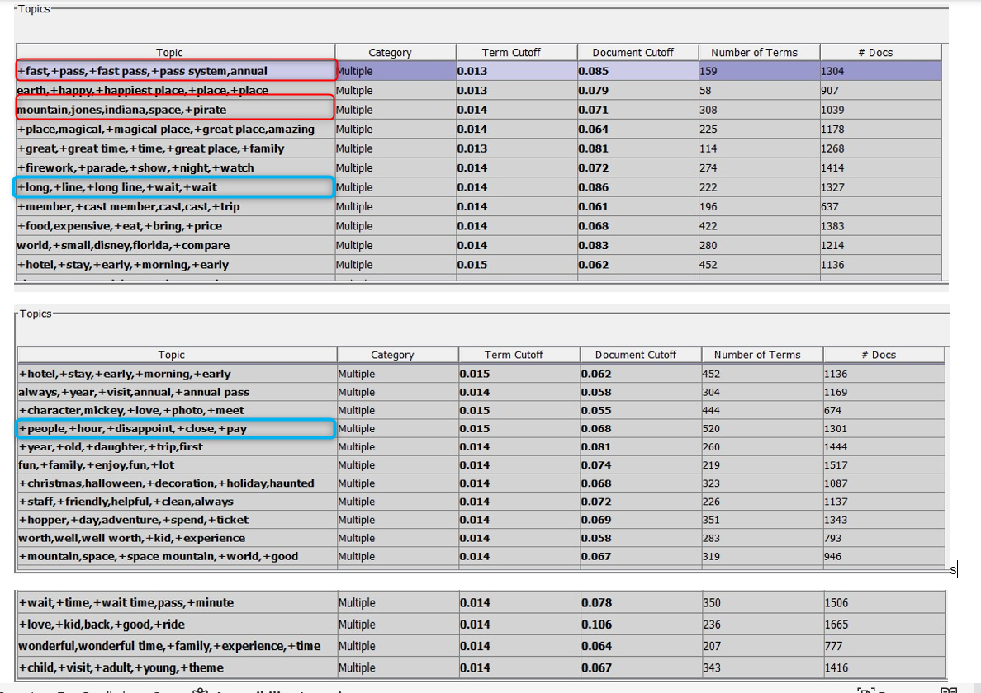

**Negative and Positive words for Paris:**

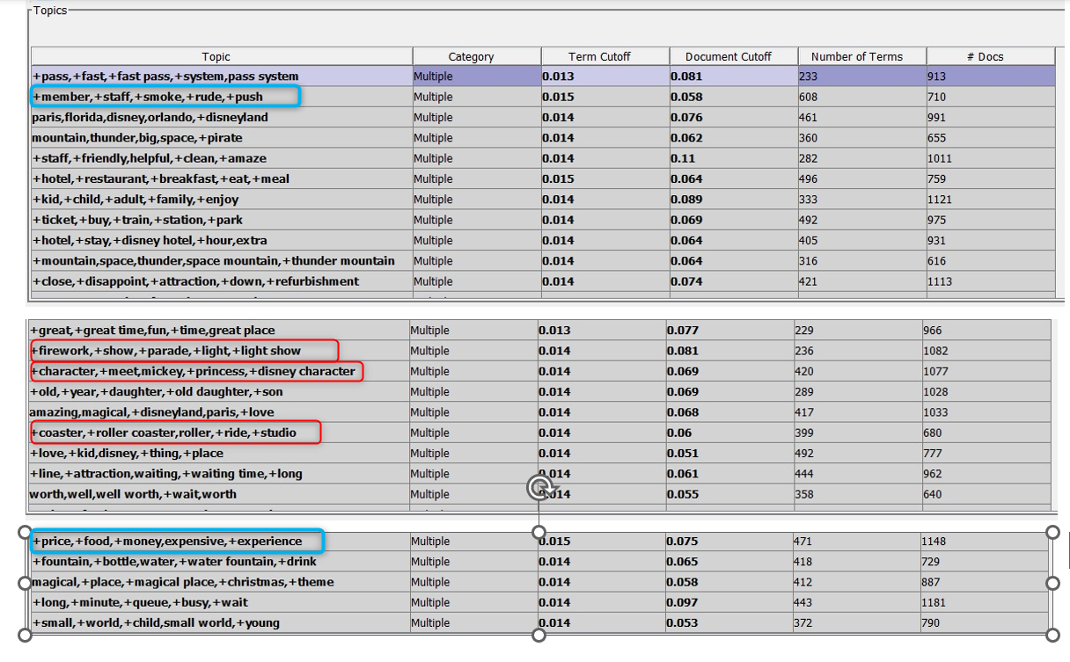

**Negative and Positive words for Hong Kong:**

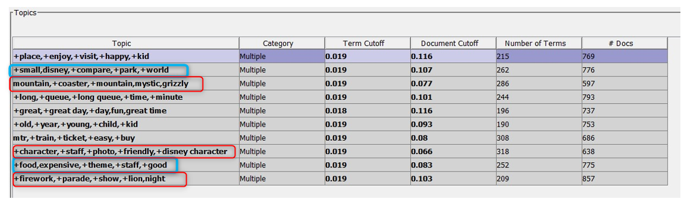

**Concept link of California:**

It displays a concept link diagram with the main branches and each branch seems to have sub-branches or terms associated with it.

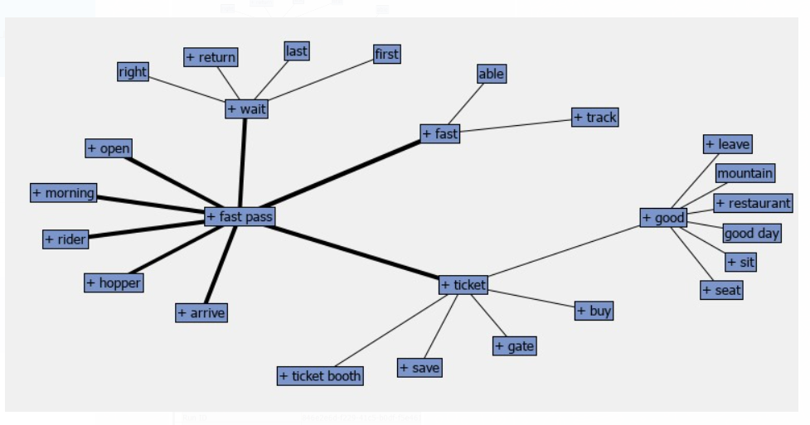

* As we saw above the positive and negative words of the california,some of the terms visible under "California" include "mountain", "morning", "restaurant", "fast pass", "good", "rider", "hopper", "ticket", and "seat"
* Terms visible under "Paris" include "wait", "open", "track", and "save".

**5. BUSINESS INSIGHTS:**

From a business perspective, understanding the positive and negative words extracted from Disneyland reviews provided us with valuable insights for improving customer satisfaction and operational efficiency. Here's how these insights can benefit Disneyland:

1. Addressing Customer Concerns: Negative words such as "expensive food" and "long queues" highlight areas where customers are experiencing dissatisfaction. By addressing these concerns, Disneyland can enhance the overall visitor experience. For example, implementing strategies to reduce food prices or optimize queue management can lead to happier guests and increased repeat visits.

2. Improving Service Quality: Negative terms like "rude staff" or "wait time" signal potential issues with customer service and operational efficiency. Disneyland can use this feedback to train staff members better, improve service responsiveness, and streamline processes to minimize wait times. Providing exceptional service can lead to positive word-of-mouth recommendations and foster customer loyalty.

3. Enhancing Attractions: Positive words such as "fireworks," "parade," and specific attraction names like "Grizzly Gulch" indicate aspects of the park that customers particularly enjoy. Disneyland can capitalize on these strengths by investing in the enhancement of popular attractions, introducing new entertainment offerings, or expanding themed experiences. Continuously improving attractions based on visitor feedback can attract more guests and drive revenue.

4. Tailoring Marketing Strategies: Understanding the positive and negative aspects of each location allows Disneyland to tailor marketing messages more effectively. Highlighting positive features in promotional campaigns can attract new visitors, while addressing negative aspects in marketing materials demonstrates a commitment to customer satisfaction and can help manage visitor expectations.

5. Maintaining Competitive Advantage: By proactively addressing customer concerns and enhancing positive aspects of the park experience, Disneyland can differentiate itself from competitors. Offering a superior guest experience can strengthen Disneyland's brand reputation, attract more visitors, and maintain its position as a top destination in the theme park industry.

Overall, leveraging insights from the sentiment analysis of Disneyland reviews allows the park to make data-driven decisions to improve customer satisfaction, enhance operational efficiency, and maintain its competitive edge in the market.

**6. CONCLUSION**

In wrapping up, the sentiment analysis of Disneyland reviews gives us a glimpse into how visitors perceive their experiences at different locations. While most feedback is positive, there are notable areas for improvement highlighted by concerns such as "expensive food" and "long queues." Addressing these issues could significantly boost visitor satisfaction. Additionally, understanding the unique strengths and weaknesses of each branch allows for tailored improvement strategies. The impressive accuracy of 90.3% achieved by the Regression model at Disneyland California emphasizes the power of data-driven insights in enhancing customer experiences. By acting on these insights to address concerns and build on strengths, Disneyland can continue offering unforgettable experiences and maintain its reputation as a top destination.

​

**7. RECOMMENDATIONS**

1. Enhanced Customer Experience: Implement dynamic pricing strategies and introduce more value meal options to address concerns regarding food pricing. Enhance queue management through the use of technology-driven solutions like virtual queue systems and app-based scheduling to minimize wait times.

2. Focused Investment in Attractions: Prioritize investments in attractions and experiences highlighted as favorites in guest reviews. Consider expansions or updates to these areas to keep the experiences fresh and engaging, ensuring repeat visits.

3. Strategic Marketing Initiatives: Utilize positive guest feedback in marketing campaigns to highlight what guests love most about Disneyland parks. Tailor marketing messages by region to attract potential visitors by emphasizing the unique attractions and experiences available at each park location.

4. Feedback Loop for Continuous Improvement: Establish a continuous feedback loop that leverages real-time data analytics to monitor guest satisfaction and operational efficiency. Utilize this system to make agile adjustments to services, offerings, and operational practices, ensuring Disneyland remains responsive to guest needs and preferences.

5. Employee Training and Engagement: Invest in comprehensive training programs for employees to enhance guest interactions, focusing on problem-solving, empathy, and customer service excellence. Encourage employee feedback to identify potential areas of improvement from an operational perspective.The "Disneyland Chronicles: Insights from Guest Reviews" project illuminates the power of text mining in extracting meaningful insights from guest feedback. By methodically analyzing 42,000 reviews, we have uncovered actionable intelligence that can significantly influence both strategic decision-making and day-to-day operations at Disneyland parks worldwide. Addressing the identified areas for enhancement and capitalizing on the strengths highlighted by guests, Disneyland can enhance its magical experience, ensuring that it not only meets but exceeds guest expectations. As the parks continue to evolve and adapt based on guest feedback, Disneyland can reinforce its legacy as the premier destination for family entertainment, where every visit is as enchanting and memorable as the last. This project underscores the importance of listening to and learning from guest experiences, marking a path forward for continuous improvement and innovation in the quest to maintain Disneyland's esteemed place in the hearts of visitors around the globe.

6. Examining the geographical backgrounds of reviewers may uncover patterns in regional tastes at Disneyland parks, allowing for the identification of visitor inclinations and reactions to certain attractions. Establishing a mechanism for instant feedback from guests while they navigate the park can significantly improve operational efficiency and elevate the total experience for visitors.